**Autumnal Treasure Basket**

[Go back](https://www.thecuriosityapproach.com/curiosity-crib/autumn/invitation-to-learning)

**Autumn**

A beautiful basket filled with gorgeous natural resources full of textures and scents.

Recipe

* A basket, one that is strong ad low enough for small children to access when sitting. Similar baskets can be found at Carla's Treasures follow [link here](https://www.etsy.com/uk/listing/621859671/natural-willow-basket-tray-montessori?ref=shop_home_active_32&frs=1)
* Natural loose parts, here we have used tree slices various sizes, Dried oranges, Lotus seed heads, Fir cones of various sizes and rattan balls. These can be sources from Grasp and Gather see link [here](https://graspandgather.co.uk/product/natural-treasure-pack/).

Regular inspection should be done to make sure that the items are safe to use and no parts that may have become damaged due to use.

A treasure basket gives babies an opportunity to explore, experiment and make choices at their own pace. To handle items and to investigate them using their mouths to suck, chew, mouth and explore using all their senses.

Once your baby can sit up unaided and has the ability to grasp and handle objects. Usually at about six months plus, you can give them a treasure basket to play with.

Always sit close by to give the baby or young child emotional support and to share children's discoveries.

Ensure time and space is provided for children to explore the objects. minimise distractions such as the TV, then just sit by baby and interact when he/ she invites you to.

Don’t leave the baby alone with the basket as there may be some items that are dangerous if played with without supervision.   
Always try to keep the basket as something special to get out on occasions throughout the day or week. This will help ensure the basket doesn't get spoilt and items retain their curiosity, awe and wonder factor.

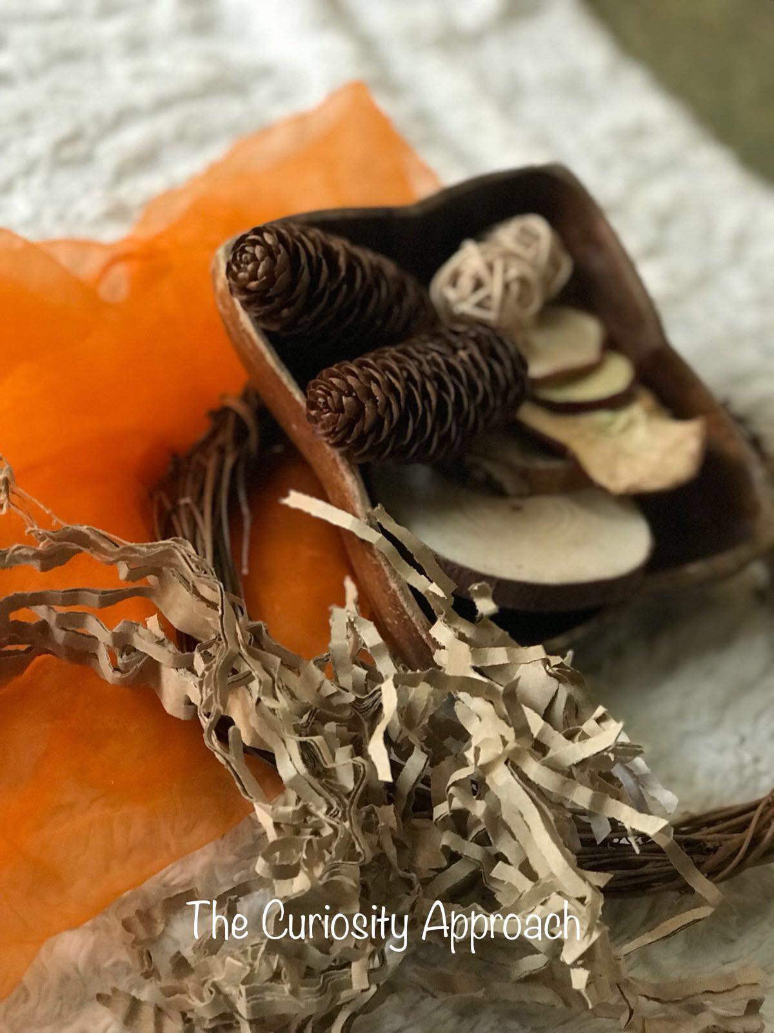

Children will love to explore and investigate the objects and items- you can add to your basket as and when you find things of interest.

Baskets enable children to develop an inquisitive mind, to notice differences in texture, colour, shape, size and weight.

From a very young age, children are experiencing scientific concepts that impact on all future learning.

Hand and eye coordination are also being developed as babies love to post items into containers.

Remember that babies are scientists and explorers, allow them to handle and explore the objects. We as adults have seen them numerous times before, however, to a baby, they are items of fascination and curiosity.

Children are born naturally and innately curious, they want to work things out and make sense of the world around them. To have control of their actions and to figure things out at their natural and rhythmical pace.  Children are born scientists and just want to explore, they aren't worried about making mistakes and they love to patiently handle, smell, bend it, break it and taste it.

Have you ever noticed how persistent babies are? How determined and focused? They just keep trying. When they can't do something they constantly try again and again. Babies are incredible little learners, who dont need expensive manufactered toys to help them learn or develop.

 Our babies and children, know best how to go about learning something.

Children need plentiful amounts of quiet time to think and process their thoughts, thinking and ideas.

This is why-with treasure baskets, there is no right or wrong way to play, investigate and explore them.

Enjoy your role as a nurturing adult who is there as facilitator and guide, to support, observe and encourage. to allow children the freedom to explore and investigate whilst keeping them safe.

*NB Risk assess your autumnal treasure baskets prior to play and never leave children unsupervised. The Curiosity approach cannot take responsibility fro treasure activities that we cannot see or supervise. You the mindful adults at your setting are responsible for keeping children happy and safe.*

