**Natural weaving**

[Go back](https://www.thecuriosityapproach.com/curiosity-crib/autumn/invitation-to-learning)

**Autumn**

Create some natural weaving frames for children to weave and thread.

To do this you will need to create a frame from 4 sticks, bound together by natural string or garden twine.

Wrap string from side to side and secure.

Provide the children with a range of natural resources that they can thread and weave in and out the string. A great place to do this activity is outside, Children can select, collect and look for natural resources independently. A frame can be created on a larger scale allowing children to join together, collaborating ideas and thinking. promoting discussion, language and conversation.

Other items that could be threaded or woven are-

Willow, Bamboo stalks or leaves, wild grasses, reeds. sticks and twigs.Petals,  flowers, straw or hay.

Garden string and twine. Petals and flower heads.

Please ensure children understand that they cannot pick all the flowers in the garden to thread.

A great tip is to ask your local florist for broken or damaged flowers or foliage.

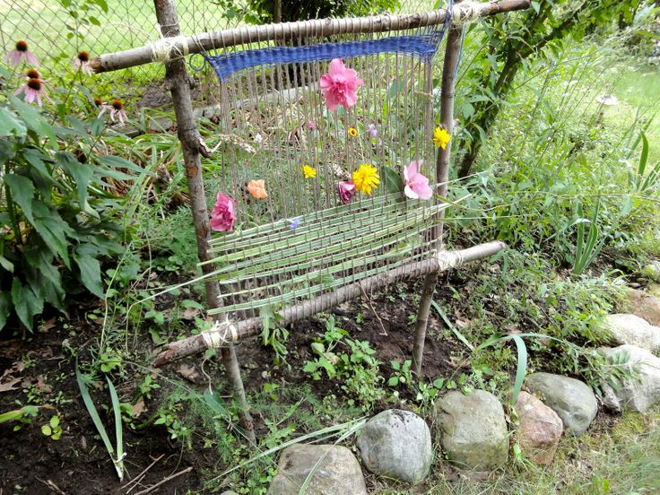

Image from Pinterest - source unknown . Credit to the great invitation to learning