**Large Scale Painting**

[Go back](https://www.thecuriosityapproach.com/curiosity-crib/autumn/invitation-to-learning)

**Autumn**

You will need...

* Large rolls of paper, lining paper from Poundland and B&M are great places to buy this cheaply
* Autumnal coloured paints in squeezy bottles
* Wetsuits are optional these are from Muddy Faces

The children squeezed paint onto the paper and used their bodies to mix and create this beautiful print. You can see from the photo how much the child is enjoying this experience.

Wetsuits are easily washed but this experience will last in the child's mind. Click [HERE](https://www.amazon.co.uk/gp/product/B0755W4XSZ/ref=as_li_tl?ie=UTF8&camp=1634&creative=6738&creativeASIN=B0755W4XSZ&linkCode=as2&tag=thecuriosit0b-21&linkId=6150597014d158c25e408109cdc01e50) to buy

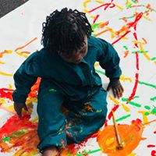

If you haven't got playsuits, that's fine too. We have a wide selection of nursery painting clothes, big T-shirts and shorts. We change the children and let them freely explore without the restriction of getting messy or being half undressed.

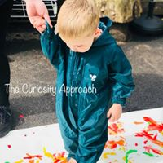

Remember some children may need time and space to explore and be confident. At curiosity Approach setting we refrain from sitting non mobile babies in tuff trays full of paint. Children should make a conscious choice if they wish to access the paint or not. This is a process of investigation and not a convayer belt to complete the whole cohort of children.



If you haven't got playsuits, that's fine too. We have a wide selection of nursery painting clothes, big T-shirts and shorts. We change the children and let them freely explore without the restriction of getting messy or being half undressed.



Remember some children may need time and space to explore and be confident. At curiosity Approach setting we refrain from sitting non mobile babies in tuff trays full of paint. Children should make a conscious choice if they wish to access the paint or not. This is a process of investigation and not a convayer belt to complete the whole cohort of children.

