**PUMPKINS**

[GO BACK](https://www.thecuriosityapproach.com/curiosity-crib/autumn/invitation-to-learning)

**Autumn**

Pumpkins are everywhere from the month of October, they're in your local supermarkets, farms and green grocers with Pumpkin event held up and down the country too and in some places you can pick you own. They're are so many different varieties available, theyre super easy to grow too. Have you got a pumpkin patch at your settings?

Look at this amazing selection one of our Managers found over the weekend, what a rich variety of colour, textures and sizes. From huge gigantic ones to tiny little ones that fit inside the palm of your hands.

Imagine being a child and walking into nursery and seeing all of these, what thoughts would be going through your head? The questions and the ideas flowing?. I wonder where they came from? What are they? That one is huge?...

They're a perfect way to provoke children into discussing their thoughts and ideas, with you eagerly listening.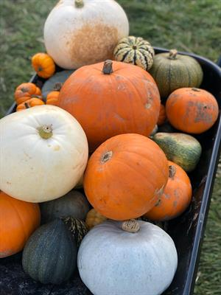

I wonder what LEARNING opportunities could be had? Here are a few suggestions...

**The great pumpkin challenge.**..Have you ever tried to transport a huge heavy pumpkin? How could you do it? what could you use? These idea can instantly be used to plan, develop, problem solve and think of ideas by setting the children a simple challenge of moving them from one place to another. This encourages team work, discussions about safety and children knowing their own limits, risk asses with the children (we don't want any children or adults injuring their backs) if they're too big and heavy can they be rolled? could a wheel barrow be used?

**Pumpkin Treasure Basket**Each pumpkin is unique in its own way, they're fascinating for younger babies to explore, feel and touch.

**Mathematical concepts-** they're different in size and weight and here we have so many... I wonder how many they're are? could they be sorted by colour, size, species? There are so many ways to support mathematical concepts through exploring these beautiful vegetables. this about how you are scaffolding the children's learning and the language you are using with the children to reinforce their thoughts and ideas in understanding these concepts. Step away from plastic counters and compare bears and encourage maths using real objects such as these.

Just a few ideas to share with you and we woild love to see your pumpkin play too, Tag us on facebook and instagram @curiosityapproach and use our hashtag #curiosityapproach

